**黄金供应链尽职调查管理制度**

**Gold Supply Chain Due Diligence Management System**

**目 录**

一、 范围 3

I. Scope 3

二、 术语和定义 3

II. Terms and definitions 3

三、 组织架构及人员职责 3

III. Organisational structure and responsibilities of personnel 3

1、组织架构 3

1. Organisational structure 3

2、 人员职责 4

2. Personnel duties 4

四、 识别及评估供应链风险 10

IV. Identifying and assessing supply chain risks 10

1、 开展供应链尽职调查，识别潜在风险 10

1、Carry out supply chain due diligence to identify potential risks 10

2、基于风险状况对供应链进行分类 13

2. Classification of supply chains based on risk profile 13

五、 供应链尽职调查程序 16

V. Supply chain due diligence process 16

1、 供应商信息收集及评估 16

1、 Supplier information collection and evaluation 16

2、根据原料的类型进行附加调查 18

2. Additional investigations based on the type of raw material 18

3、高风险情况下开启强化尽职调查 18

3. Opening enhanced due diligence in high-risk situations 18

六、 实施管理策略，应对已识别的风险 22

VI. Implementing management strategies to address identified risks 22

1、 动态评估 23

1. Dynamic assessment 23

2、 监控改进计划 25

2. Monitoring and Improvement Plan 25

3、 向执行董事指定的委员会报告调查结果 26

3. Report the results 27

七、 过程监督 27

VII. Process monitoring 27

八、 供应链风险管理体系的审查和合规评价 28

VIII. Review of the supply chain risk management system and compliance evaluation 28

九、 培训 29

IX. Training 29

十、记录保存 29

X. Record-keeping 29

十、 信息沟通机制 30

XI. Information and communication mechanisms 30

公司遵守国际国内的各项法律法规，采取合理措施，本着商业诚信原则，根据《LBMA负责任黄金指南》要求，特制定福建金玉德尚精炼科技有限公司黄金供应链尽职调查管理制度 。

The Company complies with international and domestic laws and regulations, takes reasonable measures, and in accordance with the principle of business integrity, and in accordance with the requirements of the LBMA Responsible Gold Guidelines, hereby formulates the Due Diligence Management System for the Gold Supply Chain of Fujian Jinyudeshang Refinery Tech Co.,Ltd.

1. **范围**

**I. Scope**

本制度所称的黄金供应链是指包括从黄金原料到成为终端消费者使用的最终黄金产品过程中的活动、组织、参与人员、技术、信息、资源和服务。适用于福建金玉德尚精炼科技有限公司（以下简称“公司”）黄金交易、黄金受托精炼加工等业务相关的所有供应商。

The gold supply chain referred to in this system refers to the activities, organisations, participants, technologies, information, resources and services involved in the process from the raw materials of gold to the final gold products used by end-consumers. Ltd. (hereinafter referred to as the "Company") and all suppliers related to gold trading and gold entrusted refining and processing business.

1. **术语和定义**

**II. Terms and definitions**

本制度中涉及的术语和定义均采用《LBMA负责任黄金指南》所确立的内容。

The terms and definitions covered in this system are adopted as established in the LBMA Guide to Responsible Gold.

1. **组织架构及人员职责**

**III. Organisational structure and responsibilities of personnel**

**1、组织架构**

**1. Organisational structure**

公司为黄金供应链尽职调查工作设立了专门的组织，其架构如下：

The Company has established a dedicated organisation for gold supply chain due diligence, which is structured as follows:

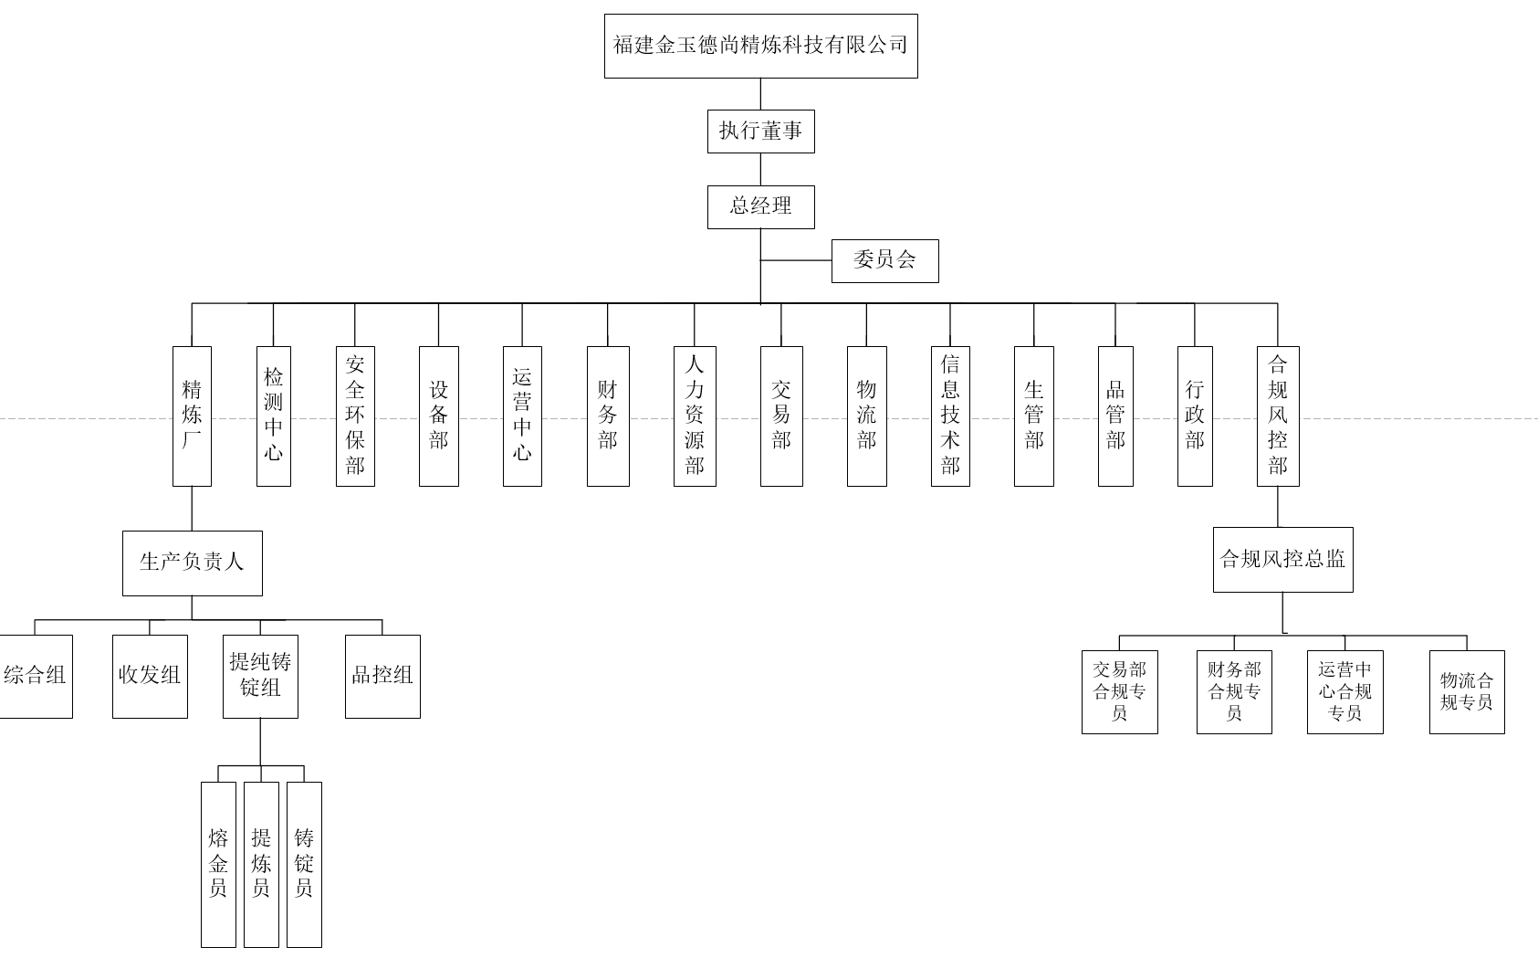

与合规相关部门架构简化如下：

The structure of the compliance-related departments is simplified below: 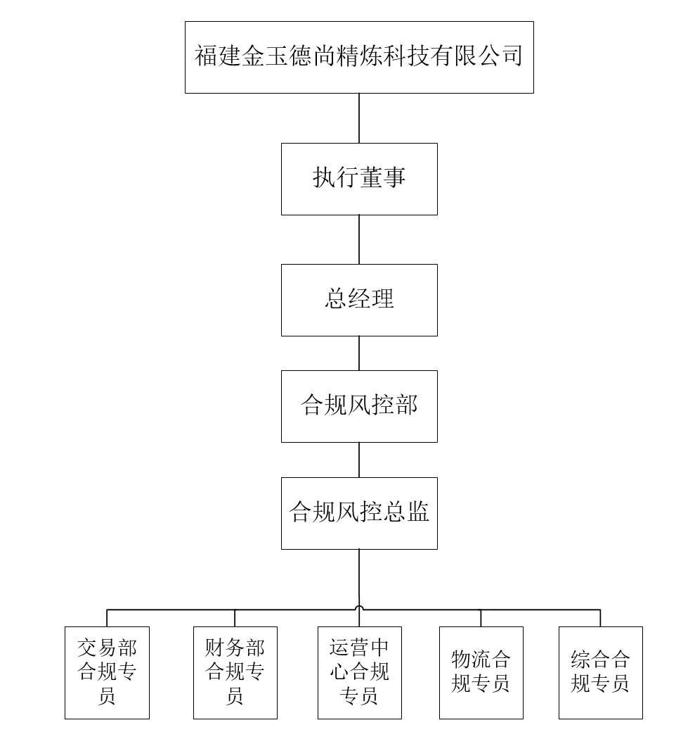

1. **人员职责**

**2. Personnel duties**

2.1**执行董事指定的委员会**

**2.1 Committees appointed by the Executive Director**

1. 审批《黄金供应链尽职调查管理制度》；

1）Approval of the Gold Supply Chain Due Diligence Management System；

1. 任命黄金供应链合规小组成员；

2）Appointment of members of the Gold Supply Chain Compliance Panel;

1. 评估合规风控官是否已经提供足够的资源支持，以支持供应链尽职调查流程、系统的运行和监控；

3) Assess whether the Compliance Risk Officer has provided sufficient resource support to support the supply chain due diligence process, system operation and monitoring;

1. 授权合规风控官审批黄金供应链尽职调查结果和风险管理策略；

4) Delegation of authority to the Compliance Risk Officer to approve the results of the Gold Supply Chain Due Diligence Survey and Risk Management Strategy;

1. 执行董事指定的委员会保留供应链的最终控制权和问责制，供应链中确定的实际和潜在风险以及所提倡的风险管理策略必须传达给执行董事指定的委员会。

5) The committee appointed by the Executive Director retains ultimate control and accountability for the supply chain and the actual and potential risks identified in the supply chain and the risk management strategies advocated must be communicated to the committee appointed by the Executive Director.

2.2**合规风控官**

**2.2 Compliance Risk Officer**

1. 起草和更新《黄金供应链尽职调查管理制度》；

1) Draft and update the Gold Supply Chain Due Diligence Management System;

1. 明确内部对供应链尽职调查政策和对流程的有效性负责；

2) Clarify internal accountability for supply chain due diligence policies and for the effectiveness of the process;

1. 协调开展黄金供应链合规管理培训；

3) Coordinate training on gold supply chain compliance management;

1. 定期评估供应链尽职调查政策和流程的有效性，以推动其持续改进；

4) Regularly assess the effectiveness of supply chain due diligence policies and processes to drive their continuous improvement;

1. 确保在高风险供应链及交易中执行适当的措施，对已识别的高风险黄金供应链或者交易采取恰当的措施减少风险直至消除风险；发现高风险黄金供应链或交易时，应及时向高层汇报并采取严格的控制隔离措施；

5）Ensure that appropriate measures are implemented in high-risk supply chains and transactions, and that appropriate measures are taken to mitigate risks until they are eliminated for identified high-risk gold supply chains or transactions; when high-risk gold supply chains or transactions are identified, they should be reported to the senior management in a timely manner and stringent control and segregation measures should be taken;

1. 负责对没有尽到风险控制的行为，进行“警告、处罚、解除劳动合同”的内部管理方式。

6) Responsible for the internal management of "warnings, penalties and termination of employment contracts" for failure to comply with risk controls.

1. 负责内部各板块合规报告的审核和汇总上报，为执行董事指定的委员会履行其职责提供恰当和及时的信息。

7) Responsible for reviewing and summarising the compliance reports of the internal boards and providing appropriate and timely information to the committees appointed by the Executive Director to perform their duties.

2.3**交易部合规专员**

**2.3 Compliance Officer, Trading Department**

1. 开展黄金供应链尽职调查的事前预控、事中监督和事后评估工作 ；

(1) Carry out pre-emptive control, monitoring and post-assessment of gold supply chain due diligence;

1. 严格执行供应链尽职调查措施和零容忍供应链、高风险黄金供应链评判标准；

2) Strict implementation of supply chain due diligence measures and criteria for judging zero-tolerance supply chains and high-risk gold supply chains;

1. 负责供应链尽职调查资料的收集整理和信息验证，评估供应链风险；

3）Responsible for the collection and collation of supply chain due diligence data and information validation, and assessment of supply chain risks;

1. 向黄金供应商宣传公司《黄金供应链尽职调查管理制度》，与合作供应商书面确认遵守相关的规定，协助与鼓励供应商构建供应链风控管理体系；

4) Promoting the Company's "Gold Supply Chain Due Diligence Management System" to gold suppliers, confirming in writing with the co-operative suppliers to comply with the relevant regulations, and assisting and encouraging the suppliers to build a supply chain risk control management system;

1. 恰当保留、归档供应商尽职调查过程中取得的资料 和文件；

5) Properly retain and archive information and documents obtained in the course of supplier due diligence;

1. 必要时，对高、中风险黄金供应链各环节进行现场调查；

6) If necessary, conduct on-site investigations of the various segments of the high- and medium-risk gold supply chain;

1. 通过合规渠道进行账务往来，例外情形均需经过核实并获得合规风控官的批准；

7) Accounts are transacted through compliant channels, with exceptions being verified and approved by the Compliance Risk Officer;

1. 供应商尽职调查资料和交易信息保存期限为至少5个财年；

8) Vendor due diligence information and transaction information is retained for a period of at least five fiscal years;

1. 尽职调查过程和黄金交易异常情况及时向合规风控官报告。

9) Due diligence process and gold trading anomalies are promptly reported to the Compliance Risk Officer.

2.4**运营中心及物流合规专员**

**2.4 Operations Centre and Logistics Compliance Officer**

1. 严格执行供应链尽职调查措施和零容忍供应链、高风险黄金供应链评判标准；

1) Strict implementation of supply chain due diligence measures and criteria for judging zero-tolerance supply chains and high-risk gold supply chains;

1. 负责收集并保存足够的黄金供应链证明文件；

2) Responsible for collecting and maintaining adequate supporting documentation for the gold supply chain;

1. 核实并记录每一批收到的产品信息，物料流转过程和重量的记录，保存化验报告，核验物料的标识和贮存；

3) Verify and record information on each batch of product received, records of material flow process and weights, maintain laboratory reports, verify labelling and storage of materials;

1. 完整保存黄金供应商的所有交易凭证和记录，保存期限为至少5个财年；

4) Keep all transaction vouchers and records of the gold supplier intact for a period of at least five financial years;

1. 出现异常情况及时封存物料并向合规风控官报告。

5) Seal materials and report to the Compliance Risk Officer in a timely manner in the event of an anomaly.

2.5**财务部合规专员**

**2.5 Compliance Officer, Ministry of Finance**

1. 严格执行供应链尽职调查措施和高风险黄金供应链评判标准；

1) Strict implementation of supply chain due diligence measures and criteria for judging high-risk gold supply chains;

1. 负责收集并保存足够的黄金供应链证明文件；

2) Responsible for collecting and maintaining adequate supporting documentation for the gold supply chain;

1. 完整保存黄金供应链的所有交易及财务凭证，保存期限为至少5个财年；

3) Keep all transaction and financial documents of the gold supply chain intact for a period of at least 5 financial years;

1. 评估黄金供应商财务数据，厘清其商业关系目的和本意信息；

4) Evaluate the financial data of gold suppliers to clarify the purpose and intended information of their business relationships;

1. 通过合规渠道进行账务往来，例外情形均需经过核实并获得合规风控官的批准；

5) Accounts are transacted through compliant channels, with exceptions being verified and approved by the Compliance Risk Officer;

1. 交易中出现异常情况及时向合规风控官报告。

6) Promptly report any anomalies in trading to the Compliance Risk Officer.

2.6**综合部合规专员**

**2.6 Compliance Officer, General Department**

1. 严格执行供应链尽职调查措施和高风险黄金供应链评判标准；

1) Strict implementation of supply chain due diligence measures and criteria for judging high-risk gold supply chains;

1. 负责收集并保存足够的黄金供应链证明文件；

2) Responsible for collecting and maintaining adequate supporting documentation for the gold supply chain;

1. 完整保存黄金供应链的所有合同及授权凭证，保存期限为至少5个财年；

3) Keep all contracts and authorisation certificates for the gold supply chain intact for a period of at least 5 financial years;

1. 协助合规风控官实施合规性管理工作，在征询关于合规工作的建议和意见后，在公司各部门人事任命中充分考虑此因素；

4) To assist the Compliance Risk Control Officer in the implementation of compliance management, and to take this into full consideration in the appointment of personnel to the various departments of the Company after soliciting suggestions and opinions on compliance work;

1. 配合合规风控官，对发现不合规或高风险来料、销售行为进行处置，对违法犯罪行为协助报送司法机关。

5) Cooperate with the Compliance and Risk Control Officer to dispose of non-compliance or high-risk incoming materials and sales behaviours found, and assist in reporting illegal and criminal behaviours to the judicial authorities.

1. **识别及评估供应链风险**

**IV. Identifying and assessing supply chain risks**

1. **开展供应链尽职调查，识别潜在风险**

**1、Carry out supply chain due diligence to identify potential risks**

遵循基于评估风险的方法进行供应链尽职调查，在与黄金供应相对方建立新的业务关系之前及保持关系期间，必须进行尽职调查。

Supply chain due diligence, which follows a risk-based approach to assessing risk, is required before entering into new business relationships with gold supplying counterparties and during the maintenance of the relationship.

公司实施黄金供应链尽职调查，遵循 以下原则：

The Company conducts gold supply chain due diligence in accordance with the following principles:

全面性原则。尽职调查应涵盖公司黄金供应链相关的各种业务和事项。

Principle of comprehensiveness. Due diligence should cover a wide range of operations and matters related to a company's gold supply chain.

重要性原则。尽职调查工作应当在全面性的基础上， 重点关注冲突地区、世界遗产地、自然保护区。

Principle of significance. Due diligence should be based on comprehensiveness, with a focus on conflict areas, World Heritage sites and nature reserves.

客观性原则。尽职调查结果应当准确、如实地揭示供应链中的风险状况。

Principle of objectivity. The results of due diligence investigations should provide an accurate and factual picture of the risk profile in the supply chain.

尽职调查分别从位置（包括来源及途径）、供应相对方、原料三个维度进行。具体识别方式可参考以下内容：

Due diligence is conducted in three dimensions: location (including source and route), supply counterparties, and raw materials. Specific identification can be found below:

1.1位置风险识别应包括但不限于：

1.1 Location risk identification shall include, but not be limited to:

1）确定黄金的来源，真实记录来源分类：矿产金、再生金、采矿副产品、官方库存；

1) Determine the source of the gold and keep a true record of the source classification: mineral gold, recycled gold, mining by-products, official stocks;

2）确定黄金的来源地或途径地，参考中国政府认可的国际制裁名单、多德－弗兰克法案第1502条、欧盟CAHRA名单、海德堡晴雨表、脆弱国家指数或类似的指数、联合国人权事务高级专员办事处或同等机构、金融行动特别工作组（FATF）的报告（包括相关国家/地区报告）、关于高风险黄金中心/转运中心和高洗钱风险国家/地区的可靠市场情报。

2) Determine the source or route of the gold by referring to the international sanctions list endorsed by the Chinese Government, Section 1502 of the Dodd-Frank Act, the EU CAHRA list, the Heidelberg Barometer, the Fragile States Index or similar, the Office of the United Nations High Commissioner for Human Rights (OHCHR) or its equivalent, the reports of the Financial Action Task Force (FATF) (including the relevant country/territory reports), and credible market intelligence on high-risk gold centres/transshipment hubs and high-risk money-laundering countries/territories.

1.2使用工具包中的KYC调查问卷对供应商进行风险识别，包括但不限于：

1.2 Risk identification of suppliers using the KYC questionnaire in the toolkit, including but not limited to:

1）使用可靠、独立来源的文件、数据或信息，识别和核实黄金供应对手方的名称、实际地址、公司注册和许可证信息；

1) Identify and verify the name, physical address, company registration and licence information of the counterparty supplying gold, using documents, data or information from reliable, independent sources;

2）使用可靠的带照片的身份证明文件，识别和验证最终受益人及相关相对方信息；

2) Identify and verify the information of the ultimate beneficiary and relevant counterparties using reliable photo identification documents;

3）确认黄金交易相对方及其最终受益人未被列入任何政府通缉的洗钱者名单或已知的诈骗犯或恐怖分子名单；

3) Confirmation that the counterparty to the gold transaction and its ultimate beneficiaries are not included in any government list of wanted money launderers or known fraudsters or terrorists;

4）了解供应商的业务和财务信息，预判有关业务关系的目的。

4) Understand the business and financial information of suppliers and anticipate the purpose of the business relationship in question.

**2、基于风险状况对供应链进行分类**

**2. Classification of supply chains based on risk profile**

公司将供应链分为零容忍黄金供应链、高风险供应链、中风险供应链、低风险供应链。

The company categorises its supply chain into zero tolerance gold supply chain, high risk supply chain, medium risk supply chain and low risk supply chain.

**2.1零容忍供应链的评判标准**

**2.1 Criteria for judging zero-tolerance supply chains**

1. 认为开采的黄金来自被指定为世界遗产或保护区的地区；

1) It is considered that the gold mined comes from areas designated as World Heritage sites or protected areas;

1. 已知回收的黄金的来源违反了国际制裁（包括但不限于联合国、欧盟、英国和美国）且得到中国政府承认；

2) The source of the recovered gold is known to be in violation of international sanctions (including, but not limited to, the United Nations, the European Union, the United Kingdom and the United States) and is recognised by the Government of China;

1. 回收黄金的供应相对方、其他已知的上游公司或它们的最终受益者是已知的洗钱者、诈骗或恐怖分子，或曾涉嫌严重侵犯人权，直接或间接支持非法的非国家武装组织，或欺骗性地谎报黄金来源。

3) The supplying party of the recovered gold, other known upstream companies or their ultimate beneficiaries are known money launderers, fraudsters or terrorists, or have been implicated in serious human rights abuses, directly or indirectly support illegal non-state armed organisations, or deceptively misrepresent the origin of the gold.

**如发现零容忍问题，不得与黄金供应相对方建立业务关系，或必须立即终止现有**

**关系。**

**Where zero tolerance issues are identified, business relationships with gold supplying counterparts must not be established or existing relationships must be terminated immediately relationship.**

**2.2高风险供应链的评判标准 、**

**2.2 Criteria for judging high-risk supply chains**

**2.2.1****再生金的高风险问题应包括但不限于：**

**2.2.1 High risk issues for recycled gold shall include, but not be limited to:**

**基于位置：**

**Location-based:**

1. 来自、经过或经由受冲突影响和人权侵犯高风险地区运输；

1) Transport from, through or via areas at high risk of conflict-affected and human rights violations;

1. 来自源于受冲突影响及高风险地区国家的黄金或被合理怀疑转运和/或不正当的来自限制出口黄金的国家；

2) Gold originating from countries in conflict-affected and high-risk areas or reasonably suspected of being trans-shipped and/or improperly sourced from countries that restrict the export of gold;

**基于供应商黄金供应相对方或其他已知的上游公司：**

**Based on supplier gold supply counterparties or other known upstream companies:**

1. 在洗钱高风险国家开展业务；

3) Operating in countries with a high risk of money laundering;

1. 具有符合基于位置高风险标准的股东或最终受益人或其他黄金供应权益；

4）Has a shareholder or ultimate beneficiary or other gold supply interest that meets the criteria for high risk based on location;

1. 具有政治风险的最终受益人；

5) Final beneficiaries with political risk;

1. 从事高风险商业活动，如军火、博彩和赌场行业、古董和艺术、教派活动及担任其领导人；

(6) Engaging in high-risk commercial activities, such as arms, the gaming and casino industry, antiques and art, and sectarian activities and serving as their leaders;

1. 在过去12个月里从高风险国家采购黄金；

7) Procurement of gold from high-risk countries in the last 12 months;

1. 与供应链中的供应商或交易相对方之间存在明显的无法解释的地理距离；

8) Significant unexplained geographical distance from suppliers or counterparties in the supply chain;

**以原料为基础的高风险类型：**

**High-risk type based on raw materials:**

1. 具有高风险供应链的中间精炼厂或交易商或从具有高风险供应链的中间精炼厂采购的交易相对方。

9) Intermediate refineries or traders with high-risk supply chains or counterparties sourcing from intermediate refineries with high-risk supply chains.

**被列为高风险的供应链将触发增强尽职调查。**

**Supply chains categorised as high risk will trigger enhanced due diligence.**

**2.3中风险供应链的评判标准**

**2.3 Criteria for judging medium-risk supply chains**

在供应商信息采集及尽职调查过程中，对于供应链尽职调查制度了解不够或配合力度不够的供应商，公司列为中风险供应链。对于这类供应商，福建金玉德尚精炼科技有限公司会加强后期培训，交易过程中持续监控其商业动机。

In the process of supplier information collection and due diligence, suppliers that do not have sufficient understanding of the supply chain due diligence system or do not co-operate sufficiently are classified as medium-risk supply chains. For this type of suppliers, Fujian Jinyu Deshan Refining Technology Co., Ltd. will strengthen the training in the later stage and continuously monitor their business motives during the transaction process.

**2.4 低风险供应链的判断标准**

**2.4 Judgement criteria for low-risk supply chains**

**对于不符合零容忍供应链、高风险供应链、中风险供应链的供应链，公司列为低风险供应链。**

**For supply chains that do not meet the criteria of zero tolerance supply chain, high risk supply chain and medium risk supply chain, the company classifies them as low risk supply chains.**

1. **供应链尽职调查程序**

**V. Supply chain due diligence process**

**1、 供应商信息收集及评估**

**1、 Supplier information collection and evaluation**

1. 与供应商签订合作协议前，业务部门根据含金物料的种类不同 ， 分别根据LBMA工具包中的调查表内容对供应商进行访谈 ；

1) Before signing a co-operation agreement with a supplier, the business department conducts interviews with the supplier based on the content of the questionnaire in the LBMA toolkit, depending on the type of gold-containing materials;

1. 采用可靠、独立来源的文件、数据或资料核实供应商基本信息；

2) Verify basic supplier information using documents, data or information from reliable, independent sources;

1. 识别客户、企业和企业收益所有人，使用可靠的独立来源文件、数据或者信息来验证其身份；

3) Identify the customer, the business and the owner of the business proceeds, using reliable independent source documents, data or information to verify their identity;

1. 公司环境社会责任报告：如 ESG （适用香港交易所 上市公司和海外上市公司） 、CSR （适用A 股上市公司） 或公司安环报告 （适用非上市公司） 等）；

4）Corporate Environmental Social Responsibility (CSR) reports: e.g. ESG (for HKEx-listed and overseas-listed companies), CSR (for A-share-listed companies) or Corporate Environmental Report (for non-listed companies), etc.);

1. 获取含金物料原料运输的方法、运输路线及 运输中间商基本信息；

5) Obtain basic information on the methods of transporting raw materials containing gold, transport routes and transport intermediaries;

1. 获取供应商商业和财务方面的详细情况、从事黄金交易目的及商业运作情况；

6）Obtain details of the commercial and financial aspects of the supplier, the purpose for which it is trading in gold and its business operations;

1. 对供应商有劳动雇佣关系的开展劳动者保护相关的调查，包括但不限于访谈、现场调查、匿名问卷；

7) Carry out surveys related to worker protection, including but not limited to interviews, on-site surveys, and anonymous questionnaires, for suppliers with labour-employment relationships;

1. 对合格供应商定期进行复查评估，针对突发事件组织应急评估；

8) Conduct regular review and assessment of qualified suppliers, and organise contingency assessment for emergencies;

1. 合格供应商信息发生变更，需及时按供应链尽职调查程序组织调查，保持档案资料库处于最新状态；

9) Changes in the information of qualified suppliers need to be organised in a timely manner in accordance with supply chain due diligence procedures to keep the archive database up-to-date;

1. 协助供应商构建风险控制管理体系。

10) Assist suppliers in building a risk control management system.

**2、根据原料的类型进行附加调查**

**2. Additional investigations based on the type of raw material**

**2.1黄金来源为再生金的进行附加调查，调查要求包括但不限于：**

**2.1 Additional investigations are conducted where the source of the gold is recycled gold, and the investigation requirements include, but are not limited to:**

1. 收集和评估供应方反洗 钱和打击恐怖主义融资方面的相关信息；

1) Gathering and assessing relevant information on anti-money laundering and combating the financing of terrorism on the supply side;

1. 获取再生黄金来源证明；

2) Obtain proof of the source of the recycled gold;

1. 受益人信息。

3) Beneficiary information.

**3、高风险情况下开启强化尽职调查**

**3. Opening enhanced due diligence in high-risk situations**

公司根据供应商企业类型、业务关系、交易类型、企业的地理位置或运输区域，用基于风险的方法决定实施尽职调查措施的程度。对应于高风险的情况，公司将采取强化的尽职调查，并采取如下的附加处理步骤：

The Company uses a risk-based approach to determine the level of due diligence measures to be implemented, depending on the type of supplier business, business relationship, type of transaction, geographical location of the business, or shipping area. For high-risk situations, the company applies enhanced due diligence and takes additional processing steps as described below:

**现场调查包括但不限于：**

**Site investigations include, but are not limited to:**

1. 实地考察或访问高风险供应链，证实供应链尽职调查结果的文件记录是否真实；

1）Site visits or visits to high-risk supply chains to confirm the authenticity of the documentation of supply chain due diligence findings;

1. 使用可信的独立来源的文件、数据和信息核实情况，供应链中涉及的环节（包括生产商、中间商、交易商、出口商和运输商）的尽职调查信息都要进行核实；

2) Use documents, data and information from credible and independent sources to verify the situation, with due diligence information from the links involved in the supply chain (including producers, intermediaries, traders, exporters and transporters);

1. 在任何交易发生前进行，或至少在业务关系开始后6个月内进行；

3) before any transaction takes place, or at least within 6 months of the commencement of the business relationship;

1. 由有能力的员工或独立的第三方顾问进行，他们与供应商不存在任何利益冲突。当公司员工进行现场调查时，他们必须承诺如实、准确地报告；

4) be conducted by competent employees or independent third party consultants who do not have any conflict of interest with the supplier. When company employees conduct on-site investigations, they must commit to reporting truthfully and accurately;

1. 在可适用的情况下咨询相关的内部和外部利息相关者（例如，地方政府机构、上游公司、国际或民间社会组织，或受影响的第三方）；

5) Consult relevant internal and external interest stakeholders where applicable (e.g. local government agencies, upstream companies, international or civil society organisations, or affected third parties);

1. 应用调查工具包中现场调查报告模板；

6) Apply the site survey report template in the survey toolkit;

1. 根据在改进计划中识别和记录的问题的数量和严重程度进行跟踪。

7) Follow up on the number and severity of issues identified and documented in the improvement plan.

*根据收到的含金材料的类型，强化尽职调查措施应当包括以下步骤。这些措施可在实地调查期间或视情况远程进行。*

Depending on the type of gold-containing material received, enhanced due diligence measures should include the following steps. These measures may be carried out during on-site investigations or remotely, as appropriate.

**对高风险中间精炼商回收黄金的强化尽职调查措施应包括但不限于：**

**Enhanced due diligence measures for gold recovery from high-risk intermediate refiners should include, but are not limited to:**

1. （在确保合规及加以解释的基础上）提供关于中间精炼商的负责任采购实践的独立鉴证报告，鉴证应：

1) Provide (on the basis of ensuring compliance and explanation) an independent assurance report on the responsible sourcing practices of intermediate refiners, which shall:

• 包括对遵循经合组织负责任采购计划的评估

- Includes an assessment of compliance with the OECD Responsible Procurement Programme

• 被中间精炼商委托开展

- Commissioned by intermediate refiners

• 在新业务关系开始之前或在精炼商实施负责任指南的合理时间框架内完成

- Completed prior to the commencement of a new business relationship or within a reasonable timeframe for refiners to implement the Responsible Care Guidelines

1. 对供应商最终受益人进行确认；

2) Confirmation of the final beneficiary of the supplier;

1. 可以将任何附加的现场调查活动委托给独立的担保方。

3) Any additional on-site investigation activities may be delegated to an independent secured party.

**对来自其他来源的高风险再生黄金采取的强化尽职调查措施应包括但不限于：**

**Enhanced due diligence measures for high-risk recycled gold from other sources should include, but are not limited to:**

1. 检查位于高风险地区的每一家黄金公司的政府关注名单信息，并参与到从交易相对方到精炼厂（包括运输商）的供应链之中；

1) Check government watch list information for each gold company located in high-risk areas and be involved in the supply chain from counterparty to refinery (including transporters);

1. 与选定的管理人员和现场人员面谈， 以确定和证实供应链尽职调查实践、

采购、反洗钱和反恐 怖主义融资程序；

2) Interviews with selected managers and field personnel to identify and validate supply chain due diligence practices,procurement, anti-money laundering and terrorist financing procedures;

1. 评估交易相对方的供应链尽职调查能力是否与风险成比例；

3) Assess whether the counterparty's supply chain due diligence capabilities are proportional to the risk;

1. 评估交易相对方风险分类方法的适当性；

4) Assess the appropriateness of the counterparty risk classification methodology;

1. 对尽职调查记录进行随机抽样评估， 以确认程序是根据交易相对方的供

应链尽职调查政策进行的，并考虑到了商业敏感信息；

5) Evaluate a random sample of due diligence records to confirm that procedures are conducted in accordance with the counterparty's supply chain due diligence policy and take into account commercially sensitive information supply chain due diligence policy of the counterparty and that commercially sensitive information has been taken into account;

1. 基于样本对交易相对方高风险供应链的现场调查报告进行评估， 并适当

考虑商业敏感信息。

6) Evaluate on-site investigation reports of high-risk supply chains of counterparties based on samples, with due consideration of commercially sensitive information.

consideration of commercially sensitive information.

1. **实施管理策略，应对已识别的风险**

**VI. Implementing management strategies to address identified risks**

根据供应商尽职调查结果，公司采取差异化风险 管理策略：

Based on the results of supplier due diligence, the Company adopts a differentiated risk management strategy:

合规风控官审查供应链尽职调查资料、《风险评估表》和《供应商评价报告》，

根据高管层授权，合规风控官依据《供应商评价报告》审批黄金供应链，决定是否与之开展或保持商务关系。

The Compliance Risk Control Officer reviews the supply chain due diligence information, the Risk Assessment Form and the Supplier Evaluation Report.Under the authorisation of the senior management, the Compliance Risk Control Officer approves the gold supply chain on the basis of the Supplier Evaluation Report and decides whether or not to enter into or maintain a business relationship with it.

公司高管层对黄金供应链保有最终控制权和最高责任。高管层谨慎选择和监督合规风控官，并给予其必要的职权以完成其职责。

The Company's senior management retains ultimate control and responsibility for the gold supply chain. Senior management carefully selects and supervises the Compliance Risk Officer and gives him or her the necessary authority to fulfil his or her responsibilities.

供应链尽职调查是动态评估过程，需要持续的风险监控，每年至少保持一次供应商风险评估。根据实时收集的信息进行判断，对已经识别的以下情况做出终止关系，或中止关系，或保持与改进计划的关系的决策。

Supply Chain Due Diligence is a dynamic assessment process that requires continuous risk monitoring and maintaining a supplier risk assessment at least once a year. Judgements are made based on information gathered in real time, and decisions are made to terminate the relationship, or suspend the relationship, or maintain the relationship with the improvement plan for the following situations that have been identified.

1. **动态评估**

**1. Dynamic assessment**

**1.1终止关系**

**1.1 Termination of relationship**

如果增强型尽职调查发现供应商存在参与洗钱、资助恐怖主义、严重侵犯人权、直接或间接支持非国家武装团体以及对黄金来源进行虚假陈述的线索，公司应立即与供应商终止合作。对于终止合作的供应商，公司应根据 国内外适用的法律要求， 向有关部门和 LBMA （如适用） 报告此 类情况。

The Company shall immediately terminate its co-operation with a supplier if enhanced due diligence reveals any involvement in money laundering, financing of terrorism, serious human rights abuses, direct or indirect support to non-state armed groups, and misrepresentation of the origin of the gold. In the case of terminated suppliers, the Company shall report such cases to the relevant authorities and the LBMA (if applicable) in accordance with applicable domestic and foreign legal requirements.

**1.2暂停关系**

**1.2 Suspension of relationships**

如果增强型尽职调查有理由怀疑供应商存在参与洗钱、恐怖主义融资、严重侵犯人权、直接或间接支持非国家武装团体、对黄金来源进行虚假陈述以及灾难性 ESG 影响的情况，公司应暂缓从供应商处采购含金物料， 直到获取更多的信息和证据。

If Enhanced Due Diligence has reason to suspect that a supplier is involved in money laundering, terrorist financing, serious human rights abuses, direct or indirect support to non-state armed groups, misrepresentation of the source of the gold, and catastrophic ESG impacts, the company should withhold procurement of gold-bearing materials from the supplier until more information and evidence is available.

一旦供应商提供了反驳初步怀疑的补充信息/数据， 或对解决ESG影响作出了及时和适当的反应，经过合规风控官批准后精炼工作就可以恢复进行。

Once the supplier has provided additional information/data to refute the initial suspicion, or has provided a timely and appropriate response to address the ESG impacts, the refining process can resume with the approval of the Compliance Risk Officer.

**1.3维持关系，但须执行改进计划**

**1.3 Maintain relationships subject to implementation of improvement plans**

如果增强型尽职调查未发现潜在问题或存在少量问题，包括贿赂、对黄金来

源进行非欺诈性虚假陈述、不缴纳应付给政府的税费和特许权使用费、 严重违反环境、健康、安全、劳动和社区相关地方立法或极有可能造成高度不利影响的 ESG 风险时，供应商能提供包含明确 改进计划和时间表的风险解决方案，并经公司合规小组评审、合规风控官批准后，公司可以与该供应商开展正 常合作关系。风险解决方案应包含明确绩效目标、基于定量和 定性分析的绩效评估指标和合理的完成日期。

If enhanced due diligence does not reveal potential problems or a small number of problems, including bribery, non-fraudulent misrepresentation of gold sources, non-payment of taxes, fees and royalties due to the Government, serious environmental violations, or other problems, it may be possible for the Government to take action.If enhanced due diligence does not identify potential issues or a small number of issues, including bribery, non-fraudulent misrepresentation of the source of the gold, non-payment of taxes, fees and royalties due to the government, serious breaches of local legislation relating to the environment, health, safety, labour and community, or ESG risks that have a high likelihood of causing a high level of adverse impact, and the supplier is able to provide a solution to the risk that includes a clear plan and timetable for improvement that has been evaluated by the company's compliance team and approved by its compliance officer, the company may enter into a normal relationship with the supplier. If the supplier can provide a risk solution with a clear plan and timeline for improvement, and after review by the Company's Compliance Team and approval by the Compliance Risk Officer, the Company may enter into a normal relationship with the supplier. Risk solutions should include clear performance objectives, performance metrics based on quantitative and qualitative analyses, and reasonable completion dates.

1. **监控改进计划**

**2. Monitoring and Improvement Plan**

采用诚信的原则，对交易相对方采取可衡量步骤、业绩监测、定期重新评估风险并向审计委员会报告。

Adoption of the principle of good faith, measurable steps for counterparties, performance monitoring, periodic reassessment of risks and reporting to the Board of Auditors.

风险检测应在开始实施改进计划的六个月内，确定消除风险的重大和可衡量的改进措施。根据六个月取得的进展，在修订后的改进计划中规定附加措施。正式评估绩效，以确定在截止日期前措施已得以适当实施（如通过独立审计、后续现场访问或远程审查）。

Risk detection should identify significant and measurable improvements to eliminate risks within six months of the start of the improvement plan. Based on the progress made in the six months, additional measures are specified in a revised improvement plan. Formally assess performance to determine that measures have been appropriately implemented by the deadline (e.g., through an independent audit, follow-up site visit, or remote review).

为促进监测活动，酌情咨询利益相关者，如地方政府机构、上游公司、国际或公民社会组织，以及受影响的第三方。考虑创建检测网络或寻求社区检测网络的支持。

To facilitate monitoring activities, consult stakeholders, such as local government agencies, upstream companies, international or civil society organisations, and affected third parties, as appropriate. Consider creating detection networks or seek support from community-based detection networks.

在改进关系确立的6个月时间段之后，当改进有限或没有可测量的改进予以证明时，暂停合作关系，直到供应商响应改进计划。在降低风险和改善表现的尝试失败后终止关系。

After the six-month time period in which the improvement relationship has been established, when improvements are limited or not evidenced by measurable improvements, the relationship is suspended until the supplier responds to the improvement plan. Terminate the relationship after attempts to reduce risk and improve performance have failed.

1. **向执行董事指定的委员会报告调查结果**

**3. Report the results of the investigation to the committee appointed by the Executive Director**

执行董事指定的委员会保留供应链的最终控制权和问责制，供应链中确定的实际和潜在风险以及所提倡的风险管理策略必须传达给执行董事指定的委员会。

The committee appointed by the Executive Director retains ultimate control and accountability for the supply chain, and the actual and potential risks identified in the supply chain and the risk management strategies advocated must be communicated to the committee appointed by the Executive Director.

发送的资料应包括：高风险供应链的相关统计；所提倡的风险减轻战略；关于改进计划实施进展和有效性的报告。

The information sent should include: relevant statistics on high-risk supply chains; risk mitigation strategies promoted; and reports on the progress and effectiveness of the implementation of improvement programmes.

1. **过程监督**

**VII. Process monitoring**

对黄金交易的过程始终保持审查和监督，以确保交易与公司对供应链的了解和风险预测相一致。根据交易性质和交易地区， 以风险为导向建立交易信息采集机制：

要求对每一批收到的黄金获取并记录以下信息：

The process of gold trading is consistently reviewed and monitored to ensure that transactions are aligned with the company's knowledge of the supply chain and risk forecasts. Risk-orientated transaction information gathering mechanisms are in place based on the nature of the transaction and the region in which it is transacted:

1. 对于再生金 ，获取供应商提供的重量记录、 运输单据 （如适用） 、高风险地区进 口和出 口的单据 （如适用） 。

1) For recycled gold, obtain weight records, transport documents (if applicable), import and export documents (if applicable) from suppliers for high-risk areas.

金料进入公司后，完成供应商编码和物料信息登记，记录往来重量，标记物料的标识和贮存，以及化验结果的保存。财务部负责往来账户通过公司账户和银行渠道进行支付。公司监督整个交易过程，确保供应链的可追溯性，并与相关行政执法部门保持紧密联系。

Once the gold material enters the company, the registration of supplier codes and material information is completed, the weight of the transaction is recorded, the marking of the material is labelled and stored, and the assay results are kept. The Finance Department is responsible for the payment of current accounts through company accounts and banking channels. The company monitors the entire transaction process to ensure traceability of the supply chain and maintains close contact with relevant administrative and law enforcement authorities.

如在交易过程中出现高风险物料，由运营中心负责标识、隔离存放，通知合规风控官进行核实，由业务部门通知供应商或相关执法部门，对物料进行处理。业务部门对出现高风险的供应商重新进行尽职调查。

If high-risk materials appear in the course of transactions, the Operations Centre is responsible for marking and segregating the materials for storage, notifying the Compliance and Risk Control Officer for verification, and the business department notifying the suppliers or relevant law enforcement authorities. The business department re-conducts due diligence on suppliers that appear to be high-risk.

1. **供应链风险管理体系的审查和合规评价**

**VIII. Review of the supply chain risk management system and compliance evaluation**

合规风控官每年组织对供应链风险管理体系进行审查，评价适宜性和有效性，依据审查结果编写《合规报告》，提交高管层审批。

The Compliance and Risk Control Officer organises an annual review of the supply chain risk management system, evaluates its suitability and effectiveness, and prepares a Compliance Report based on the results of the review and submits it to the senior management for approval.

安排对供应链管理体系进行独立的第三方审计。

Arrange for an independent third-party audit of the supply chain management system.

1. **培训**

**IX. Training**

合规风控官负责制定培训计划，定期组织培训，推动供应链风险管控的了解和巩

固，内容包括但不限于：

The Compliance Risk Control Officer is responsible for developing training plans and organising regular training to promote the understanding and consolidation of supply chain risk control consolidation, including but not limited to:

1. 《LBMA负责任黄金指南》及LBMA网页更新信息；

1) The LBMA Responsible Gold Guide and LBMA webpage updates;

1. OECD冲突矿产规定；

2) OECD Conflict Minerals Regulations;

1. 供应链尽职调查政策；

3) Supply chain due diligence policy;

1. 尽职调查管理制度；

4) Due diligence management system;

1. 其他要求。

5) Other requirements.

**十、记录保存**

**X. Record-keeping**

收集并保存足够的供应链证明文件和记录，按照供应链尽职调查系统的标准来评判供应链风险等级和实施风险减缓措施，以证明公司充分且持续地完成了黄金供应链尽职调查和风险管理工作。

Collect and maintain sufficient supply chain supporting documentation and records to demonstrate that the Company has adequately and consistently completed its gold supply chain due diligence and risk management efforts by rating supply chain risks and implementing risk mitigation measures in accordance with the standards of the Supply Chain Due Diligence System.

供应链尽职调查信息、证明文件、评估记录和交易记录等信息文件保存要求不得

少于 5 个财年。

Requirements for retention of information documents such as supply chain due diligence information, supporting documentation, appraisal records, and transaction records should not be less than five fiscal years.

1. **信息沟通机制**

**XI. Information and communication mechanisms**

社会和内部员工如发现黄金供应链管理或交易过程中的违规事项或异常情况，可

[以通过电话0591-62199999-9077或申述邮箱chenlingling@decent9999.cn与我们进行沟通，申述邮箱定期由合规风控官查阅，福建金玉德尚精炼科技有限公司对举报人信息保密，保护申述过程中的隐私。](mailto:以通过电话0591-62199999-9077或申述邮箱chenlingling@decent9999.cn与我们进行沟通，申述邮箱定期由合规风控官查阅，福建金玉德尚精炼科技有限公司对举报人信息保密，保护申述过程中的隐私。)

Society and internal employees who find irregularities or abnormalities in the management or trading process of the gold supply chain can communicate with us by phone 0591-62199999-9077or representation mailbox chenlingling@decent9999.cn, which is regularly accessed by the Compliance and Risk Control Officer, and Fujian Jinyu Deshun Refining Technology Co., Ltd. maintains the confidentiality of the whistleblower's information and protects the privacy of the representation process.

签发人：福建金玉德尚精炼科技有限公司

Issuer:Fujian Jinyudeshang Refinery Tech Co.,Ltd.

2023年 6月

June 2023